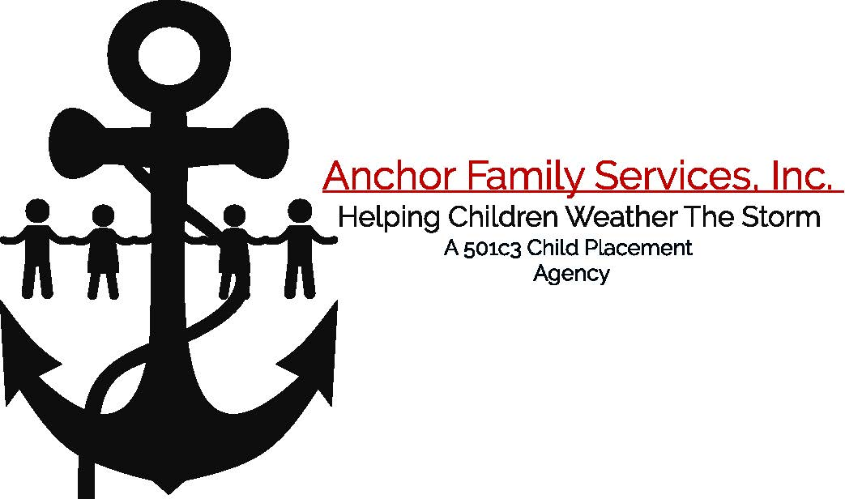

PARENT PROFILE

MY FAMILY HISTORY

Name of person completing this form:

1. List the people who lived with you when you were growing up. Indicate your age when you lived with each person.

Name | Relationship | Age Range

2. Was there anyone not in your home or immediate family with whom you were especially close and why?

3. When you were growing up, what were ways for members of your family to show the following feelings:

A. Happiness

B. Love/Affection

C. Anger

D. Disappointment

E. Frustration

F. Sadness/Depression

G. Stress

4. How were you disciplined as a child and who was the primary disciplinarian in your home?

5. How old were you when you left home?

A. Why did you leave?

B. How did you and your family feel about your leaving?

6. List any current and previous marital and/or significant intimate relationships in sequential order, most current to earliest.

Marriage or Significant Relationship | Name of Spouse or Significant Person | Date of Marriage or Beginning of Relationship | Date Marriage or Relationship Ended | Reason Marriage or Relationship Ended
1
2
3
4
5

7. Please list any children you have. If this is not applicable to you indicate so here______

Name | Age | This Child Corresponds to which Relationship in Question 6 | Where they live & with whom | Relationship to you (birth child, stepchild, adopted, not legally related) | Visitation Schedule  (if applicable)

8. Identify your emotions about the ending of your marriage/relationship(s) and describe how you handled those emotions.

9. If you have remarried, or entered into a new relationship with someone other than your children’s biological parent, how did your children adjust to the new person?

10. How did you meet your spouse or the person with whom you are living?

11. How long have you:

A. Known each other?

B. Been married?

C. Been living together?

12. What do you think was the main reason you married or entered into a relationship with this person and the main reason why you have stayed together?

13. What do you like the most about your spouse or partner? What do you think your spouse or partner likes most about you?

14. What would you most like to change about your husband or partner? What do you think your spouse or partner would like to have you change?

15. What do you most like about being married and/or living with someone?

16. What do you least like about being married and/or living with someone?

17. What would make you want or consider a divorce or an ending of the relationship?

18. What was the biggest disappointment or loss you have had in your life and how did you cope with it?

MY SCHOOL AND WORK HISTORY

1. How many grades did you complete in school (junior high, high school, college, graduate school)?

A. If you did not complete high school, what were the reasons?

B. If you have attended college, what was your field of study and what degree did you receive?

2. How important will grades and school performance be for the child placed in your home?

3. What are your school expectations for a child placed in your home?

4. Since leaving school, please list (from first to current job):

Places you have worked | Job Title | Length of Stay | Reason for Leaving

5. How do you think becoming a foster parent might affect your work?

MY INTERESTS IN AND EXPECTATIONS OF FOSTER PARENTING

1. What made you think about becoming a foster parent at this time?

2. Have you ever been in foster care? Were you adopted?

Do you know anyone who has been in foster care or adopted?

If yes to any of these questions, please explain:

3. Would you consider adopting a child from foster care?

4. Are you planning to have a child or children by birth in the future?

If no, please explain:

5. As you think about becoming a foster parent:

A. What do you think you will like most?

B. What do you think you will like least?

C. What do you think others in your family will like most and least about having a new child in your home?

6. If you have parenting experience, what have you enjoyed most about being a parent?

7. What have you disliked most about being a parent?

8. What forms of discipline do you find to be most effective?

9. Under what circumstances do you think it is OK to spank or physically discipline a child?

10. Have you ever been a parent to someone else’s child?

11. Please list any agencies you have previously contacted to become a foster parent:

Agency/Location | Outcome of Contact

Signature Date

